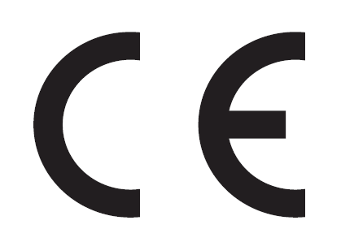
EC Declaration of Conformity
According to the Machinery Directive 2006/42/EC
For the following equipment:
Product :Drum Mixers
Type Designation/Trademark: .CM140L
Serial Number :
Manufactures Name :Yangzhou Ailida Electromechanical Manufacturing CO.,LTD
Manufactures Address :WeigaoRoad, Gaoyou Town Industrial Park 225600 Gaoyou City, Jiangsu Province PEOPLE’S REPUBLIC OF CHINA

Refer to in this declaration conforms with the following directive(s):
Machinery Directive 2006/42/EC

The company named above will keep on file for review the following technical documentation:
Operating and mainteriance instructions
Technical drawings
Risk assessment
Description of measures designed to ensure conformity
Other technical documentation, e.g quality assurance for design and production

Name and address of the person (established in the Community) compiled the technical file:
Yangzhou Ailida Electromechanical Manufacturing CO.,LTD
WeigaoRoad, Gaoyou Town Industrial Park 225600
Gaoyou City, Jiangsu Province PEOPLE’S REPUBLIC OF CHINA

Responsible for making this declaration is the:

Manufacture √

Authorized representative established within the EU(if applicable):
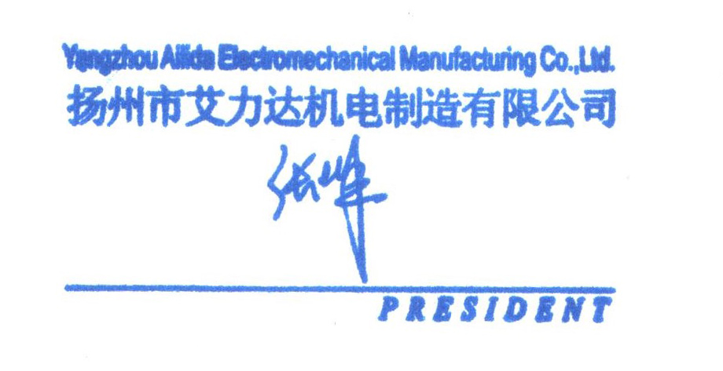

-----------

(place) (date) (company stamp and legal signature)

