ELECTRONIC DIGITAL CALIPER
OPERATING INSTRUCTIONS
- APPLICATIONS:
1.Comparisons between plug and hole 2.Deviation from reference size A
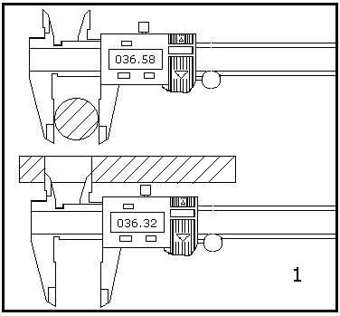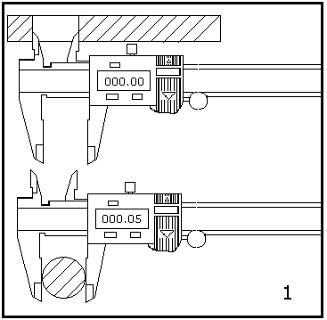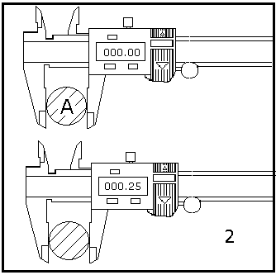
3.Measuring of bottom thickness 4.Measuring of centre distance 5.Measuring where display
between two identical holes faces opposite
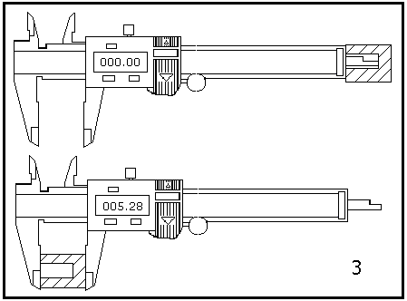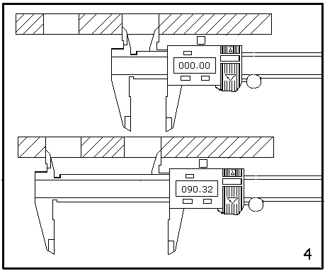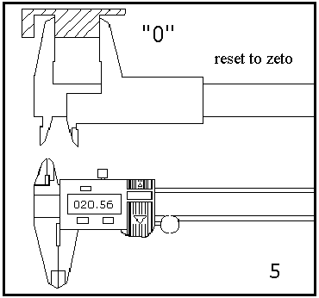
- INSTRUCTIONS
- Keep body face clean, prevent liquid material from getting into slider to destroy electronics
- Face should be cleared by petrol.,body lubricated by few clock oil.Acetone and alcohol mustn’t be used.
- Don’t remove end lid without using output intereface.Output end shouldn’t be contacted with metal in order to protect electronics against damage.
- Other notes refer to conventional caliper.
●SPECIFICATIONS AND FUNCTIONS:
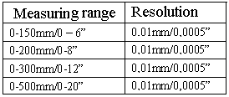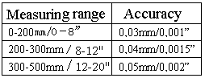
Repeatability. 0.01mm or 0.0005”
Maximum measuring speed: 1.5m/sec or 60”/sec
Measuring system: non contaction linear CAP measuring system.
Display: LCD display,minus sign “-”, character in 4.7mm/0.185” height for 5digits, small digit“5”
and “IN” sign for inch measuring unit.
Battery : one silver oxide battery 1.5V for one year of continuos use. Low of battery warning
by flashing display
Operating temperature: 0℃- +40℃
Storage temperature: -20℃-+70℃.
Influence of humidity: not important within 0 to 80% of relatieve humifity
Data output: serial output for interface with host computer or printer
Data processing
Interface (option): Functions: data storage ,processing & printing.with software of quality control.
- TROUBLE SHOOTING
Trouble | Cause | Remedy
Five digits jump simultaneously  once per second about | Battery voltage is under 1.45V | Remove the cover and replace battery
The display can’t count. | Circuit accident | Put out battery and reset it in after 30sec.
Only display 000.00 or IN 00.00 | Both function buttons and slider’s signal end  short out. | Remove the cover, put button’s spring in  idea condition
Function buttons non active | Spring out of shape caused by violent  pressing buttons | Ditto
Reading error for full length is  ≤0.1mm | Dirts get into sensor . | Remove the cover and slider assembly ,jet sensor’s face with clean pressure air (≤51kg/cm²), clear it with fewpetrol for dirt preventing
LCD screen no display | - Battey hasn’t good contact.  - Battey voltage is under 1.1V | - Remove the cover.keep good contact for battery  - Replace battery
  - METRIC/INCH change over (true conversion)
  - Zero setting (zero setting at any position within the measuring range)
  - Battery change cover
  - Data output socket
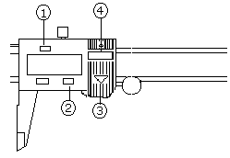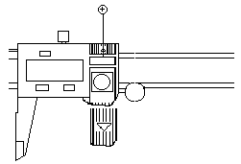
Battery replacement

